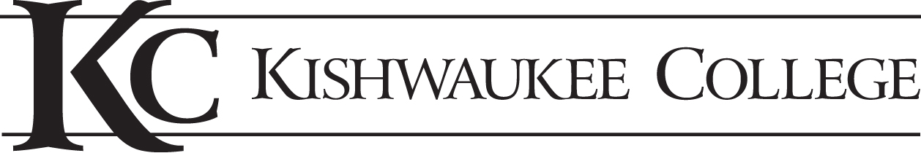
minutes
Welding Technology Advisory Committee Meeting
Date | time 4/9/2018 at 6:00pm in room A1411
|Meeting Called to Order at 6:10pm by Zachery Caccia

Attendance
Members Present:
Rachel Hofer—Blount and International/ Woods Equipment
Craig Shurson—Etnyre International Ltd.
Gene Fogel—DeKalb/Ogle Workforce Development
Charlie Brown—Dun-Rite Tool/Cresswood
Ryan Butzman—Dun-Rite Tool/Cresswood
Chuck Bergsmith—Sauber Mfg

KC Members Present:
Zachery Caccia—Faculty, Welding Technology
Joanne Kantner—Vice President of Instruction
Matthew Feuerborn—Dean of Career Technologies
Bette Chilton—Dean of Health and Education

Approval of Consent Agenda
Spring 2018 Enrollment Report followed by discussion of spring enrollment.
Review of meeting minutes from Fall 2017.

Discussion of Industry Trends and Potential Training Needs—Questions for Employers
- What are your current or projected employment needs of your organization for welding and fabrication over the next 2-3 years?
- Etnyre needs 15 welders ASAP
- Ryan from Cresswood stated there were Fabrication shop, assembly and machine shop needs as well. Charlie and Ryan are looking at upcoming retirement needs of his Division at Cresswood. They are currently interviewing and considering one of our current students.
- Chuck from Sauber just hired two welders; one of whom is currently finishing up our program. Currently staffed with welders.
- Are the majority of your new entry-level positions filled by individuals with previous training or candidates you are training in-house?
- If they can get the talent, the employers will take it. Otherwise they will train themselves.
- At Cresswood, it is about the culture and finding someone who can fit in well. Looking for the right person. Some training is nice but they will continue to train if they need to.
- Attitude is everything.
- Does the Kishwaukee College Welding Technology program provide the level of training that you require of new employees? Too much or too little?
- Cresswood needs GMAW, SMAW, FCAW, the basic skills, shop math, communication, and print reading.
- Pipe welding/ Pipe fitters union
- GTAW is in demand
- Craig from Etnyre is looking for basic skills.
- Cresswood does rigging of very large parts. Ryan asked if we taught any rigging. The 10 hour OSHA course a very brief amount of rigging.
- If there is an employer demand for welding and fabrication training, what are you recommendations for getting more students into this training pipeline?
- It’s good paying solid work
- Want long term relationships
- Reach out to the high school level
- Needs to be local students that find the interest
- To what extend are you willing to help support the efforts necessary to grow enrollments and support the program?
- Encourage the younger folks to get engaged
- Cresswood: Core philosophy is flexibility
- Focusing on specific job skills/cross-training/skills matrix
- Have employees from Cresswood come and demonstrate from the workforce to a class from a Master Welder.

New Curriculum/Certificate Program and AAS Degree Status
12 booths in use M-F very full time. Adding courses as curriculum is revised.

Intro to fabrication WT 133 is now a required course for the Basic Welding Certificate.

Three additional classes will be added to the WT offerings as part of an advanced pathway: Layout I, Advanced GMAW / FCAW, and ASME Pipe. Also looking at an integrated manufacturing program that would provide a vast number of skills that are common core and the foundation for what is needed for an AAS degree. The manufacturing degree would be available to WT, AET, ELE, and CAD students. WT 116 Fundamental Welding Processes will be required for all students as part of this degree. This will likely require additional WT 116 sections.

Matt met with Tom Crouch from KEC today. KEC welding students may be moving to Sycamore High School. If this happens it will free up prime time lab space for more Kishwaukee sections.

2 CAD, 2 architectural design, ELE, Maintenance portion, precision machining

Consolidate everything down this hallway into one manufacturing wing.

Cert levels for welding: Basic certificate takes one year. Only sequencing is stick welding I and II.

Basic certificate assures safety and foundations.

More advanced Welding certificate also offered.

Current students have to test into math and possibly be remediated if unable to pass the competency test.

There are now multiple ways to demonstrate proficiency in math.

Within CAD there is GD&T included.

Would like to integrate in the Metrology course and other MT courses.

Matt asked for a recommendation for a prerequisite for TIG welding. Fundamentals and Oxyfuel was recommended by Cresswood.

Zach states he can see a marked difference in the students who have taken Oxyfuel before Tig Welding since they are way ahead of the others. All agreed that this pathways sounds like it would work to improve the success of those in Tig welding.

Matt thinks it could be Fundamentals or Oxyfuel as a prerequisite.

Also language clean up is occurring in the curriculum.

New Business
KC is losing a WT adjunct. Need a new certification, welding instructor. We are looking for an AWS CWI. Matt is looking for recommendations.

Next Meeting
Monday, November 12, 2018 at 6pm.

Administrators remind members to contact them with any concerns.

Meeting adjourned at 7pm.

